Inkollu Akashdhar

** E-Mail**: [akashdhar.apssdc@gmail.com](mailto:akashdhar.apssdc@gmail.com) **Mobile**: 9550835760

 **PRESENT ADDRESS:**

20G/303, Sahara States,

Mansoorabad,

L.B.nagar,

Hyderabad,

500068.

Looking for a challenging Opportunity in where I can utilize my knowledge and skill for the advancement of the

Company and gaining expertise and building professional career.

**PROFILE SUMMARY**

* 2+ years of experience in web application development using java(J2EE) and spring framework.
* Currently working on HCL internal project .
* Worked on projects like biometric based attendance using Aadhaar, Automated Certificate Generation for Colleges, Batch Upload, Designing of UI Components for Reports and Dashboards, storing of data on Cloud using s3, Automated mail service, Writing queries for reports.
* Proficient in finding and resolving malfunctions, using exceptional technical and communication skills.
* Ability to express technical concepts clearly to people with no technical background.
* Adept in JAVA and Web Applications using Rest Structure.
* Conversant with HTML, CSS, JS, Bootstrap 3, jQuery, Angular, Spring framework, iBATIS, Spring MVC, AWS.
* An effective communicator with good interpersonal, logical thinking & analytical abilities.

**Experience profile**

* Worked in APSSDC (Andhra Pradesh State Skill Development Corporation), Jubilee hills, Hyderabad, from April 2016 to June 2108.
* Currently working as, a software Developer at HCL.

**SCHOLASTIC**

­­ 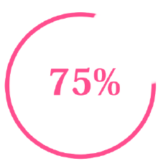 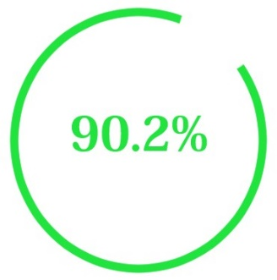 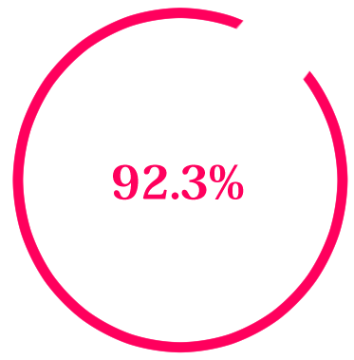

2016 2012 2010

B. TECH DEGREEE INTERMEDIATE HIGH SCHOOL

Avanti Scientific and Research Academy Vikas junior college Siddhartha High School

**Recent Projects**

**Project #1 JUN 2017 – Aug 2016**

Title : Employee Management System

Client Organization : APSSDC (Andhra Pradesh State Government)

Environment : JDK 1.7, Spring MVC, PostgreSQL, Angular Js, Eclipse.

Team Size : 3

Role : Server Side

**Description :**

Employee Management System is mainly developed for employee registration it is based on IRIS Authentication and in this we have maintained their attendance by IRIS kit and track them by IRIS based attendance (When they will come and leave). Project also contains employee transfer system and termination of employee. And their working and issue reports.

**Responsibilities:**

* Analyzing the requirements.
* Used Core java, Spring MVC framework.
* Involved in developing.
* Resolving the production issues reported by the client users.

**Project #2 May 2016 – June 2107**

Title : Learning Management System (LMS)

Link : http://202.65.133.69:8181/edx/

Client Organization : APSSDC (Andhra Pradesh State Government)

Environment : JDK 1.7, Spring MVC, PostgreSQL, Angular Js, Eclipse.

Team Size : 2

Role : Server Side and UI

**Description :**

This project mainly deals with the maintenance of our own openedx platform and building

Custom reports and logins.

**Responsibilities:**

* Analyzing the design document.
* Used Core java, Spring MVC framework.
* Involved in developing.
* Resolving the production issues reported by the client users.

**TECHNICAL PROFILE**

|  |  |  |
| --- | --- | --- |
| **SKILL** | **EXPERIENCED** | **AWARENESS** |
| **Languages** | Java 7.0 | C |
| **Operating Systems** | Linux, Windows |  |
| **Web Technologies** | Html, JavaScript, CSS, Bootstrap, Angular Js | jQuery,less,Sass,Ts |
| **Database Software’s** | PostgreSQL |  |
| **JSE-Technologies** | Core java, Collections framework |  |
| **Servers** | Tomcat 7.0 |  |

.

**IT SKILLS**

**EXTRA CURRICULUM**

* Awarded 1st rank in model presentation on rotating led display and a PPT on wireless power transmission.
* Actively participated in Inter College Tech Fest Competition held at IIT Hyderabad, sreenidhi and many others.
* Involved in various cultural activities held at School and College level.
* block level topper at college level.

**PERSONAL SNIPPETS**

Name : Inkollu Akashdhar

Date of Birth : 24th March 1994

Languages Known : English, Hindi and Telugu

Nationality : Indian

Hobbies : Watching Anime and Browsing Internet

Interest : Website development ,game development, animation,

Maya and Zbrush character designing.

Father name : Inkollu Vidyadhar

Mother name : Vasanta Lakshmi

**Place**: **Hyderabad INKOLLU AKASHDHAR**